**Template for Sensors interfacing with Arduino**

1. Infrared (IR) Sensor
2. Passive Infrared (PIR) Sensor
3. Ultrasonic Sensor
4. Temperature and Humidity (DHT11) Sensor

**Evaluation Criteria:**

1. Connection diagram.

2. Code for Arduino for each sensor.

3. Successful execution of all four sensor activities.

**Performance-15 Marks**

**Submission-10 Marks**

**Team**

|  |  |  |  |
| --- | --- | --- | --- |
| **Sr No** | **Roll No** | **Name** | **Work Done** |
| 1 | 16010423075 | Ritesh Gorule | Arduino assembly |
| 2 | 16010423076 | Ritesh Jha | Arduino assembly |
| 3 | 16010423077 | Ritwik Mohanty | Code execution |
| 4 | 16010423078 | Riya Amin | Code execution |
| 5 | 16010423079 | Rohan Jobanputra | Code execution |

**Fill your details as per following points**

* **Photos of Actual implementation**

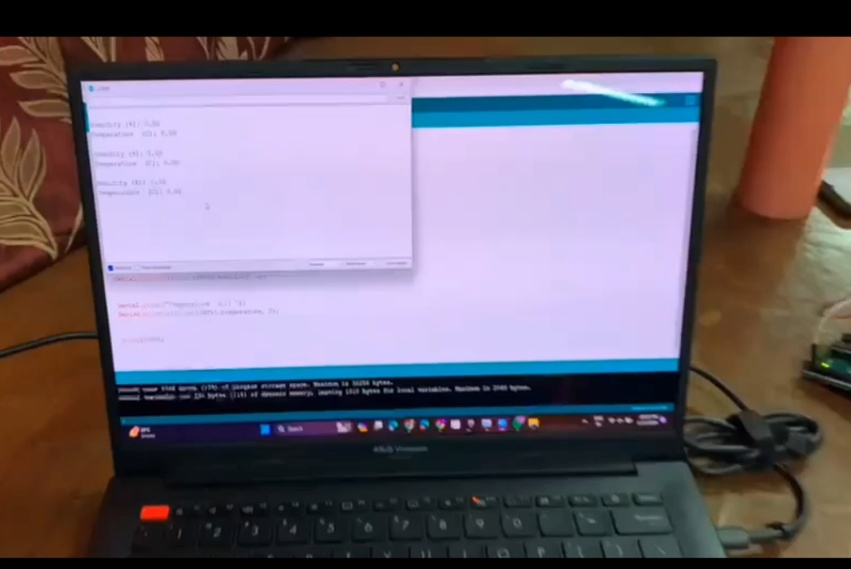

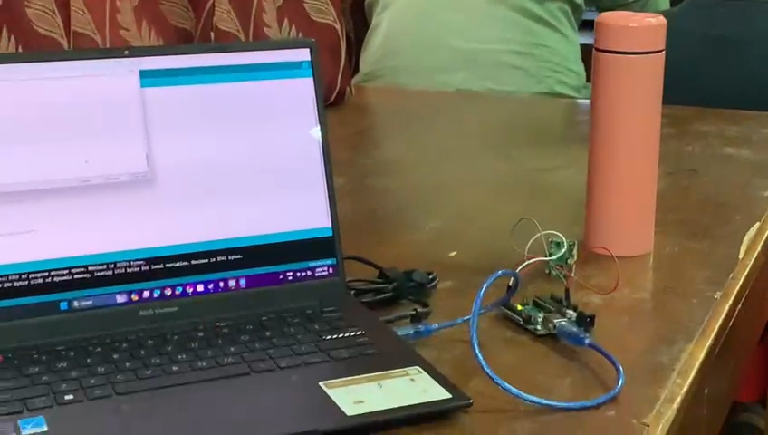

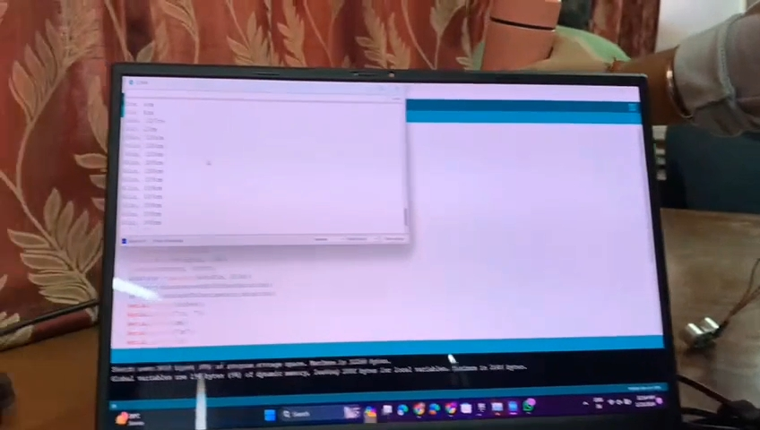

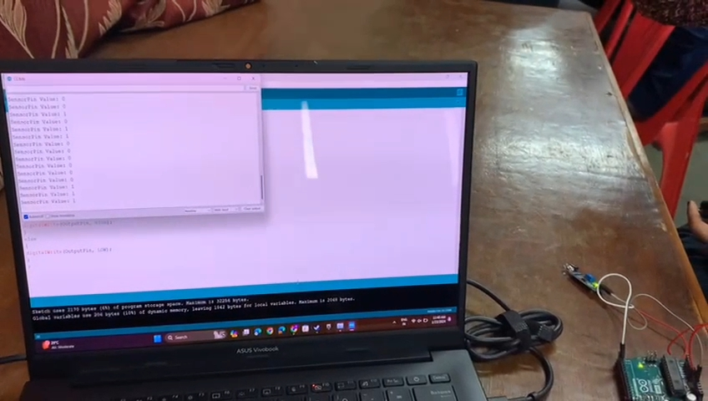

* **Video of Actual implementation**

** **



* **Conclusions**

In conclusion, Arduino projects are a great way for tech-focused students to build skills, enhance their resumes, and prepare for careers in the tech industry. Whether you’re interested in robotics, data analysis, or Internet of Things (IoT) applications, an Arduino board can provide a wide range of opportunities to learn and grow. By working on Arduino projects, you can gain experience with hardware and software development, circuit design, programming, sensors, actuators, and other important technologies.